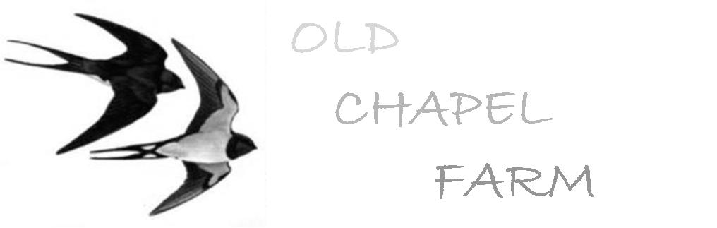Volunteers Application Form

Name:
Date:
Address:
Telephone Number:
Email:
Gender:
Nationality:
Date of Birth:

Length of stay required:
Preferred date or month of arrival:
Any special dietary requirements:
Are you happy to share a room or yurt?
Do you have any medical conditions – mental or physical that could affect your ability to do physical work?
Do you smoke?
Do you have a driving licence?
Do you intend to bring a laptop?
Have you lived in a rural area before?

Work You Are Interested In (please tick)

Gardening/groundwork | Livestock | Environmental work
Cooking | Woodland management/green woodworking | Eco Building/carpentry
Housekeeping | Office/computers/fundraising | Project supervision
Sewing/weaving | Beekeeping | Building maintenance
Food processing ( Dairy/jams etc)

Experience In Any Of These

What especially do you hope to gain/learn from your time here?

Your Interests

Why did you choose this farm?

